Flower Classification: Analysis of Data Augmentation Strategies

Diego Acevedo, Samantha Colbert-Neal, Pallav Kamojjhala
Department of Engineering, University of San Diego
AAI 501: Introduction to Artificial Intelligence
Prof. Friesen
12 August 2024

Flower Classification: Analysis of Data Augmentation Strategies
Our project is all about creating an AI tool that can recognize different kinds of flowers. As machine learning and computer vision have advanced, AI has grown beyond just simple tasks like identifying flowers. Now, it’s being used in all sorts of areas. The main goal of our project is to build a strong and reliable neural network that can accurately spot various flower types in images. We're aiming to develop an AI that works well across a range of real-world situations, using some of the latest deep learning techniques.
To make this happen, we’re using a dataset from Kaggle called "Flowers," which has images of 16 different flower species. This dataset is pretty challenging because the photos vary a lot in how they’re taken—different angles, lighting, and backgrounds, which makes it a tough but perfect training ground for our model. The variety in this dataset is similar to what we’d expect in real-life situations, so it’s a great fit for our project.
The project involves several key steps: collecting and preparing the data, picking and training the model, and then testing how well it works. We’re focusing on convolutional neural networks (CNNs) because they’ve proven to be good at tasks like this (Li, Zhu, & Li, 2023). Our goal is to find the best model that is not only accurate but also efficient and practical for real-world use.
This report will walk you through everything we did—from the methods we used to the challenges we faced. We hope that by sharing our process, others can learn from our experience in developing this flower detection AI.
Approach
This work is using TensorFlow and Keras to create and evaluate many convolutional neural networks (CNNs) for flower categorization. The first stage of data preparation was loading a 15,740 collection of pictures from 16 different floral categories. From this dataset, sets for training (80%) and validation (20%). Keras's Sequential API was used for building all of the models; the Adam optimizer was coupled with the Sparse Categorical Cross entropy loss function.
Designed simply with three Conv2D layers each followed by Max Pooling2D layers, a Flatten layer, a dense layer, and finally an output layer for classification, the initial model constructed in the model-building stage had Further models were built utilizing several data augmentation techniques in order to find how each of the other models—Random Flip, Random Crop, Random Translation, Random Rotation, Random Zoom, Random Contrast, and Random Brightness—would effect model performance (Daffodil Insights, 2024). By combining all these augmentation techniques, another model was constructed to evaluate the total influence on performance.
Each of these models trained ten times; the training and validation accuracy were noted and plotted to show their respective performance.

Key Findings
Basic Model
Starting strong, this model began to overfit during the fourth epoch, perhaps running against a wall. It was performing somewhat poorly on fresh, unseen data but well on the training set. It produced a validation accuracy of 58.70%.
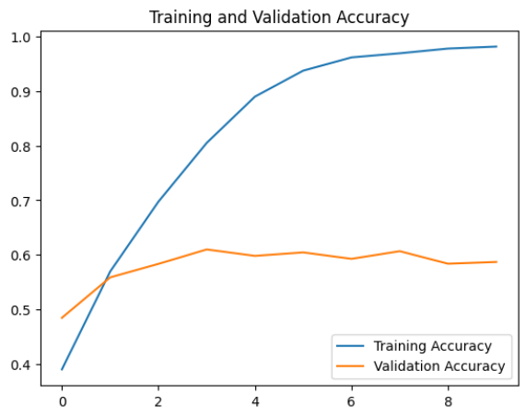

Random Flip
Including random flips turned out to be a wise action. This model developed to a validation accuracy of 68.58%, a good increase from the fundamental model.
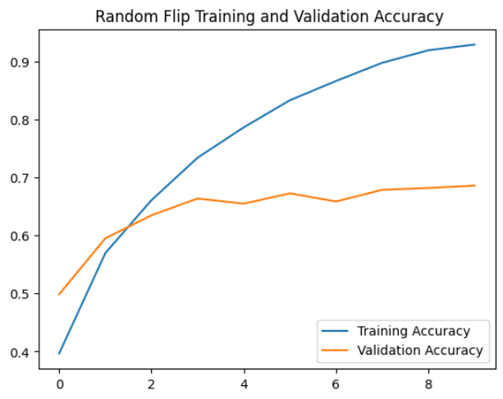

Random Crop
Not every enhancement worked out. With a validation accuracy of 52.35%, this one performed truly poor. Cropping seems to have severed vital portions of the blossoms, producing less than ideal outcomes.
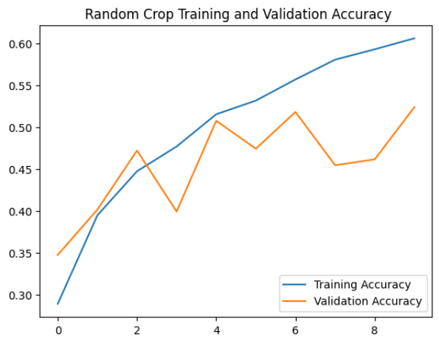
Random Translation
With a validation accuracy of 72.52%, this model—random translation—was the champion. Moving the photos about seems to have made the model more flexible since it enabled it to learn to identify flowers wherever in the picture.
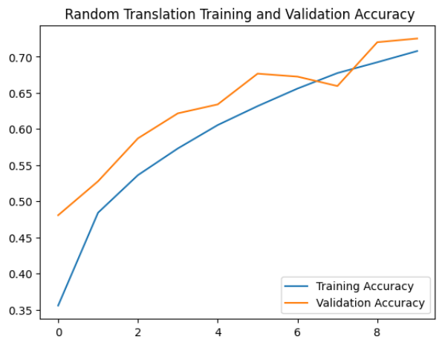

Random Rotation
With a validation accuracy of 71.86%, Random Rotation Model likewise performed admissibly. Since flowers can show at any angle in images, rotating the pictures didn't seem to greatly confuse the model too much.
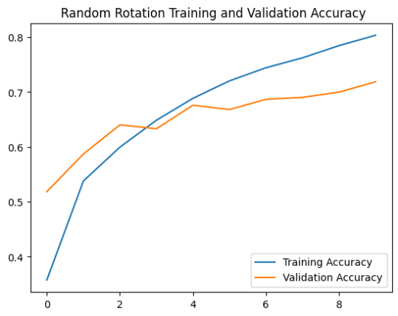
Random Zoom
With a 67.50% validation accuracy, this model performed rather well. Random Zoom Model Though it wasn't as strong as rotation or translation, it nonetheless improved upon the fundamental idea.
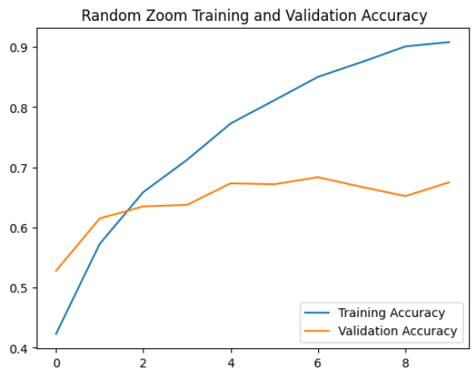

Random Contrast & Brightness
With validation accuracy of 62.13% and 61.79%, these augmentations had less influence. The performance of the model wasn't much changed by varying brightness and contrast.
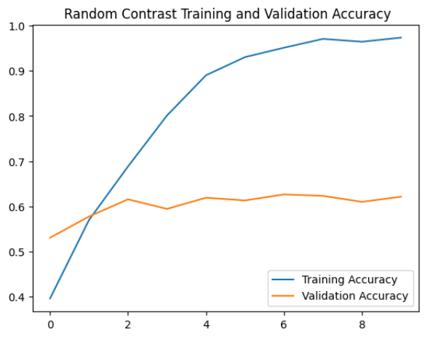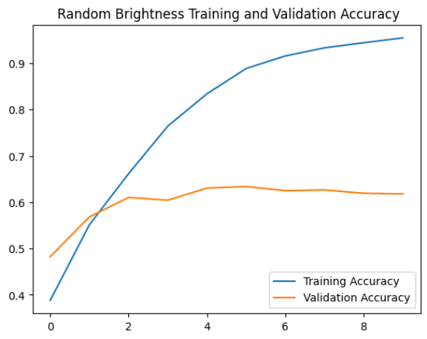
All Data Augmentation Layers
Surprising as it was, this model performed the worst—with a validation accuracy of just 47.49%. Combining too many augmentations turns out to make the work more difficult rather than beneficial.
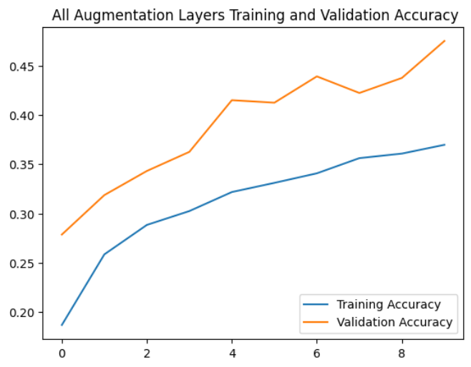
Conclusion
Turning out the best performance with a validation accuracy of 72.52%, the Random Translation Model. Given translation augmentation allowed the model to become more flexible in identifying flowers, independent of their placement in the image—a common circumstance in real-world images—this model most likely performed well. The model that aggregated all the augmentations failed most likely because the combined alterations made it difficult for the model to learn effectively. The Random Translation Model found the perfect equilibrium and improved performance without overloading the model with too many modifications.

References
Altamirano-Gomez, G., & Gershenson, C. (2023). A comprehensive review of convolutional neural network architectures and their applications. IEEE Access, 11, 4567-4583. https://doi.org/10.1109/ACCESS.2023.4567114Daffodil Insights. (2024). What is data augmentation in deep learning? Techniques and applications. Daffodil Software. https://insights.daffodilsw.com/blog/what-is-data-augmentation-in-deep-learning
l3llff. (n.d.). *Flowers*. Kaggle. Retrieved from []]]]]]]]
Li, W., Zhu, N., & Li, M. (2023). Optical convolutional neural networks: Methodology and advances. Applied Sciences, 13(13), 7523. https://doi.org/10.3390/app13137523
Russell, S., & Norvig, P. (2021). Artificial intelligence: A modern approach (4th ed.). Pearson.
ScienceDirect. (2024). Data augmentation in deep learning: A comprehensive survey. ScienceDirect. https://www.sciencedirect.com/science/article/pii/S0957417422007763
Taye, M. M. (2023). Theoretical understanding of convolutional neural network: Concepts, architectures, applications, future directions. Computation, 11(3), 52. https://doi.org/10.3390/computation11030052
Tzafestas, S. G. (2018). Synergy of IoT and AI in modern society: The robotics and automation case. Robotics & Automation Engineering Journal, 3(5), Article 555621. Retrieved from https://sandiego.instructure.com/courses/12847/files/1792425?wrap=1

